1. Summarize chapters 1 and 2 (1. OVERVIEW, 2. ENVIORNMENT SETUP) in the text book.

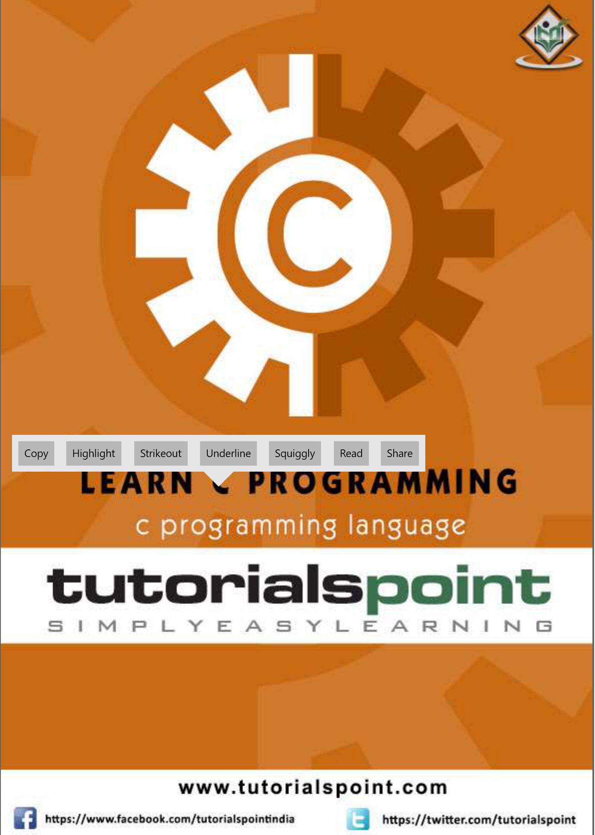

1. Try to install the Microsoft Visual Studio Community 2019 based on the C lan_L_02_Fin.pptx file.